



adges UI components library

**Component ID #1 – ex-identity-card - v1.0.0**

## Document Control

## Version History

|  |  |  |  |
| --- | --- | --- | --- |
| Version | Date | Author | Reason for Change |
| **1.0.0** | 2019-11-5 | Mahmoud |  |
| **1.1.0** | 2019-11-5 | Shaheen |  |
| **1.1.0** | 23/09/2020 | Rijin Mukundan |  |
|  |  |  |  |
|  |  |  |  |
|  |  |  |  |
|  |  |  |  |
|  |  |  |  |

## Review History

|  |  |  |
| --- | --- | --- |
| Version | Reviewer | Date |
|  |  |  |
|  |  |  |
|  |  |  |
|  |  |  |
|  |  |  |
|  |  |  |
|  |  |  |

Table of Contents

Document Control 2

Version History 2

Review History 2

1. Document and components Purpose. 4
2. General Information. 4
3. How to use. 5
4. Component features and configure. 6
5. How to configure component. 7
6. Examples 8

# 

# Document and components Purpose.

The purpose of the document is to guide how use and configure **ex-identity-card** component.

# General Information.

Component Name: Identity-card.

Extension Theme: ex-identity-card.

Owner: Mahmoud.

Version no: v1.0.0

Design

Identity Card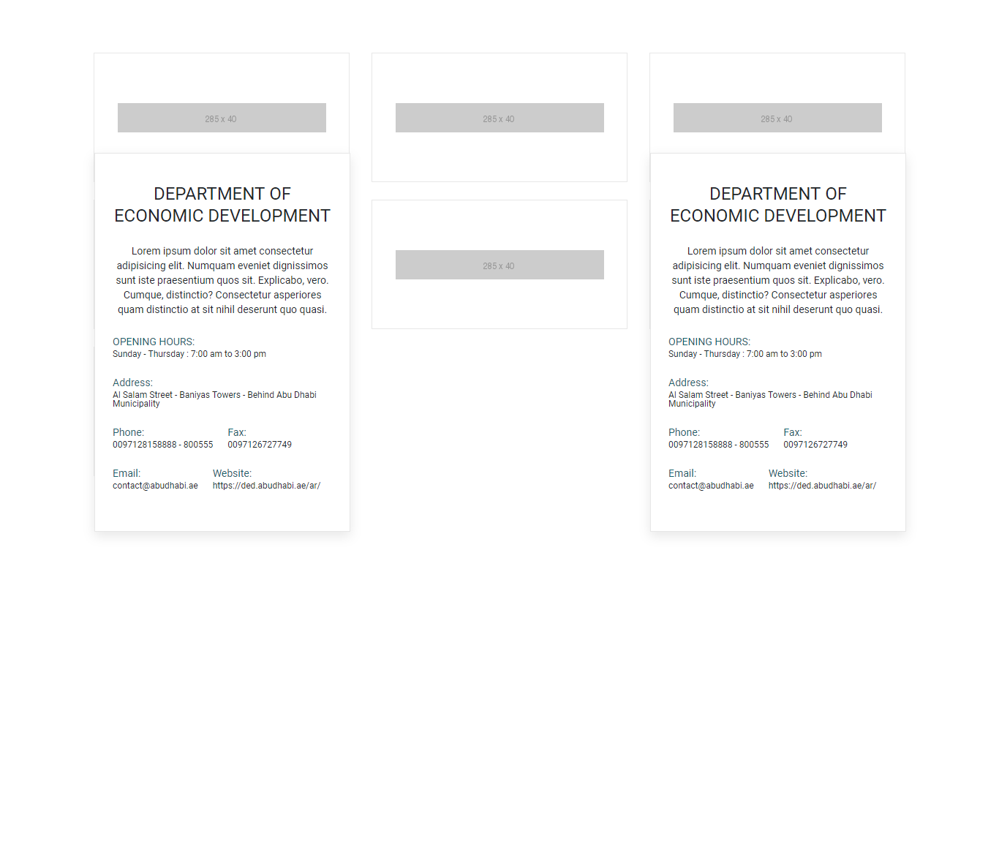

Identity-card double expand

pasted-image.tiff

# How to use.

1. The available commands for this project .
   1. Compile : npm run gulp compile -- –path ex-identity-card –extension
   2. Compile & include under ADGE tenant : npm run gulp compile -- –path ex-identity-card –extension –full –dest [ADGEFolder]
   3. Deploy : npm run gulp deploy -- –path ex-identity-card –extension
2. *Now project have full copy from this extension theme under the project theme and you can apply the project brand guideline and configure component based on project needs.*

# Component features and configure.

You have access now to configure component with the below item.

$identity-card-bg:$white-color !default;

$identity-card-height:175px !default;

$identity-card-border:1px solid $grey-200 !default;

$identity-card-hover-container-top:100% !default;

$identity-card-hover-container-visability:hidden !default;

$identity-card-hover-container-opacity:1 !default;

$identity-card-hover-container-padding:25px !default;

$identity-card-hover-container-transition:all 0.3s ease !default;

$identity-card-hover-container-width:30px !default;

$identity-card-contact-section-fs:12px !default;

$identity-card-contact-section-lbl-color:#17626C !default;

$identity-card-contact-margins:20px !default;

$identity-card-after-hover-top:0 !default;

$identity-card-after-hover-visability:visible !default;

$identity-card-after-hover-opacity:1 !default;

$identity-card-after-hover-z-index:1 !default;

$identity-card-after-hover-bg:$white-color !default;

$identity-card-after-hover-box-shadow: 0 , 6px , 15px 0 , color-opacity(#d0d0d0 , 0.5) !default;

$identity-card-link-color:$secondary-color5 !default;

$identity-card-titlelink-color:$grey-700 !default;

$identity-card-home-title-color:$primary-color !default;

$identity-card-double-expand-desc-line-height:23px !default;

$identity-card-double-expand-transition: 0.5s ease !default;

$identity-card-double-expand-normal-card-height: 255px !default;

$identity-card-double-expand-bg-position-x: left !default;

$identity-card-double-expand-bg-position-y: bottom !default;

$identity-card-double-expand-bg-color: $white-color !default;

$identity-card-double-expand-hover-card-height: 565px !default;

$identity-card-double-expand-hover-font-weight: 700 !default;

$identity-card-double-expand-img-height: 60px !default;

$identity-card-double-expand-overlay: $grey-600 !default;

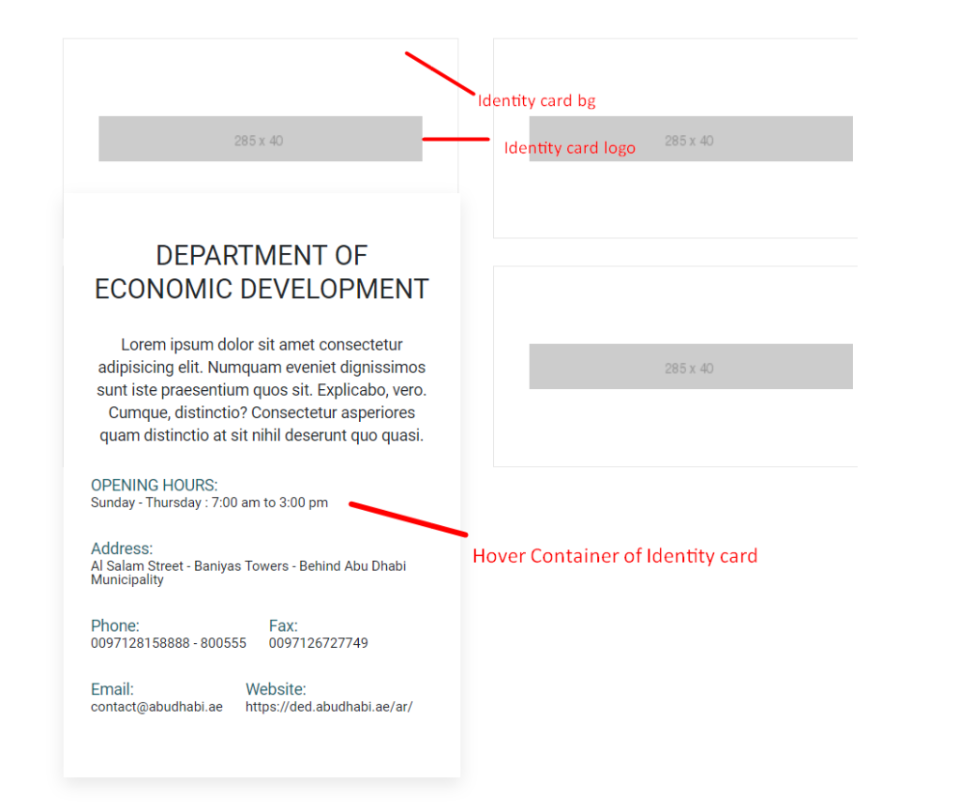

# How to configure component.

There are various ways to configure the component:

1. **CSS Class Configuration (on the variant)**

These styles can be applied in the variant to get the desired result

|  |  |
| --- | --- |
| Feature | Modifier |
| --- | .ex-identity-card--double-expand |

1. **Adding Built-In or Bootstrap Class (on the variant)**
   1. Spaces, Font weights, Display, Position properties etc can be added by bootstrap classes
      1. i. Spacing: <https://getbootstrap.com/docs/4.0/utilities/spacing/>
      2. ii. Flex: <https://getbootstrap.com/docs/4.4/utilities/flex/>
      3. iii. Font: <https://getbootstrap.com/docs/4.0/content/typography/>
   2. These classes should only be added to match the design
   3. For built-in classes check 7 Below to see the entire list
2. **SCSS Variable Override (on the _override.scss file)**

To configure the component we can take the above variables from section **4. Component features and configure** and add them to: adge-ph2/themes/<ADGE>/vars/_override.scss, this file with your desired changes to match the design.

1. **Complete style override**
   1. This should be the last and final option if the above 3 didn’t get you the desired output
   2. This is overwriting the SCSS of the component by adding your own style to it
   3. **Note: Take permission before doing this override**
   4. Instructions:
      1. Open the file /adge-ph2/themes/<ADGE>/sass/overrides.scss and add your own SCSS styles to override the faulty component.

# Dependencies

components-identity-card.css

slick-min.js

slick-init.js

components-identity-card.js

# Examples

Examples1:

For example background of the card

$identity-card-bg:#FFF !default;

For example card height

$identity-card-height:175px !default;